DEALS TO BELLEVUE

Boasting a vast network of green spaces with parks, beaches, and miles of nature trails, as well as a bustling downtown, there are always a variety of things to do in Bellevue, WA. Book a trip to Bellevue via Seattle-Tacoma International Airport on Virgin America. Live it up at 35,000 feet with WiFi, on-demand entertainment, and more on every flight.

(MARKET IMAGE HERE)

Find Deals From These Cities

INSERT FARE GRID FROM / TO Version (if available!)



Top Things To Do in Bellevue

Below we’ve highlighted a few top Bellevue attractions to try when you visit for business or pleasure.

* Visit the Bellevue Botanical Garden. This charming garden offers a bunch of little surprises everywhere you go, making it entertaining for all ages. In addition to exploring its various serene gardens, with trails that take you from one garden to the next, be sure to walk across the 150-foot long suspension bridge that goes across a wooded ravine for some extra excitement.
* Only in town for the night? Treat clients and co-workers to Bin on the Lake. With a locally-sourced menu, amazing views across Lake Washington and a deep wine list, it will leave an impression.
* Explore or picnic at Bellevue Downtown Park. Located in the heart of Bellevue, this park has lovely features, including a scenic one-half mile promenade, a 240-foot wide waterfall that cascades into an expansive pond, a 10-acre lawn area, and formal gardens that make for a mesmerizing stroll.
* Be adventurous and take the Bellevue Zip Tour. Located in Eastgate Park, you’ll soar through the forest on zip lines high above the city, experiencing the thrill of being way up in the air while taking in some spectacular views.

Travel Tips and Resources

[Must-Dos in Bellevue](http://www.visitbellevuewashington.com/things-to-do)

[Bellevue Hotels](http://www.tripadvisor.com/Hotels-g58349-Bellevue_Washington-Hotels.html)

[Bellevue Restaurants](http://www.tripadvisor.com/Restaurants-g58349-Bellevue_Washington.html)

[Bellevue Shopping Guide](http://www.visitbellevuewashington.com/shopping)

[Bellevue Nightlife and Entertainment](http://roadtrippers.com/us/bellevue-wa/activities-nightlife-and-party-bellevue-5989?lat=40.80972&lng=-96.67528&z=5)

[Bellevue Travel Tips](http://www.visitbellevuewashington.com/about-bellevue)

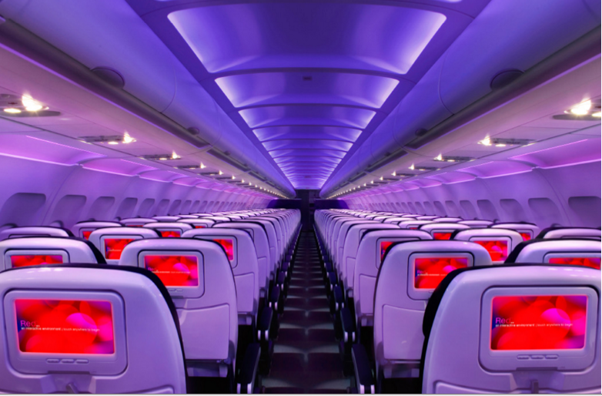

Main Cabin Main Cabin Select First Class

(add links to Cabin Class Pages)

Ready. Set. Fly.

Book your Mood-lit Ride to Bellevue.

When traveling to Bellevue, fly into Seattle-Tacoma International Airport with Virgin America. From the airport, you’ll be just over twenty minutes from Bellevue. Fly with us and you’ll enjoy refined amenities such as mood-lit cabins, custom-designed leather seats, and inflight WiFi. Plus service that’s catered to your needs in order to provide you with the most relaxing, convenient, and pleasant in-flight experience around.

Take a Virtual Tour

Add Terms & Conditions